Project - Low Level Design
On
Healthcare Content Generator

  - Course Name:GenAI

Institution Name: Medicaps University – Datagami Skill Based Course

Student Name(s) & Enrolment Number(s):
Sr no | Student Name | Enrolment Number
1. | Kashish Bilala | EN24CA5030079
2. | Komolika Vyas | EN24CA5030083
3. | Aayush | EN22IT301004
4. | Danish Shaikh | EN22IT301032
5. | Prakhar Jain | EN24CA5030122

Group Name:D12-04
Project Number: 04
Industry Mentor Name:
University Mentor Name: Ajaj Khan
Academic Year:2025-2026

Table of Contents
- Introduction.
  - Scope of the document.
  - Intended Audience
  - System overview.
- System Design.
  - Application Design
  - Process Flow.
  - Information Flow.
  - Components Design
  - Key Design Considerations
  - API Catalogue.
- References

1.Introduction
The Healthcare Content Generator is a Generative AI–based application developed to assist healthcare professionals in creating structured and professional medical content efficiently. In the healthcare industry, preparing patient summaries, medical explanations, and documentation requires significant time and effort. This project aims to simplify that process by automatically generating well-structured healthcare content from simple user inputs.
The system is built using Python, a Vector Database, and a Large Language Model (LLM) API, following a Retrieval Augmented Generation (RAG) approach. It retrieves relevant healthcare information from a vector database using embedding-based similarity search and then uses an LLM to generate accurate and properly formatted content. The application also includes a user-friendly interface that allows users to enter healthcare topics and quickly receive detailed and organized medical documentation.

  - Scope of the document

This document provides a detailed description of the Healthcare Content Generator system, including its objectives, architecture, functionalities, and technologies used in the development of the application. It explains how the system utilizes Python, a Vector Database, and a Large Language Model (LLM) API to generate structured healthcare content from user inputs.

The document outlines the system design, workflow, and implementation process, along with the interaction between the frontend and backend components. It also describes how the system uses a Retrieval Augmented Generation (RAG) approach to retrieve relevant healthcare information and generate accurate medical content, helping healthcare professionals create documentation more efficiently.

  - Intended Audience

This document is intended for healthcare professionals, developers, project evaluators, and students who are interested in understanding the design and functionality of the Healthcare Content Generator system. It provides detailed information about how the application generates structured healthcare content using Generative AI technologies.

The document is also useful for system developers and researchers who want to understand the implementation of Python, Vector Databases, and Large Language Model (LLM) APIs in building an AI-powered healthcare content generation system. Additionally, it can help project reviewers and examiners understand the overall architecture, workflow, and purpose of the application.

  - System overview

The Healthcare Content Generator is an AI-powered application designed to generate structured healthcare content based on user-provided topics. The system allows users to input a healthcare-related query, after which it processes the request and produces professional medical content such as patient summaries, diagnosis explanations, and treatment recommendations.

The system uses Python and Flask for the backend, while a modern frontend interface enables user interaction. It follows a Retrieval Augmented Generation (RAG) approach where healthcare data is stored in a vector database. When a user enters a topic, the system retrieves relevant information through similarity search and sends the context to a Large Language Model (LLM) API, which generates accurate and well-formatted healthcare content for the user.

2.System Design
The Healthcare Content Generator system is designed using a modular architecture that integrates a frontend interface, backend processing layer, vector database, and a Large Language Model (LLM) API. The design ensures efficient processing of user inputs and generation of structured healthcare content. The system follows a Retrieval Augmented Generation (RAG) approach to improve the accuracy and relevance of the generated content.
The system begins with a user interface (frontend) where users enter a healthcare-related topic or query. The request is sent to the backend API developed using Python and Flask, which processes the input. The backend converts the input into embeddings using an embedding model and performs a similarity search in the vector database (FAISS) to retrieve relevant healthcare information. The retrieved context is then combined with the user query and sent to the LLM API, which generates structured healthcare content such as patient summaries, symptoms, diagnosis explanations, and treatment recommendations.
The generated content is returned to the backend and then sent back to the frontend interface, where it is displayed to the user in a clear and structured format. This design ensures efficient data retrieval, accurate AI-generated content, and a smooth user experience.

2.1 Application Design

The application is designed as a modular, scalable, and layered system that leverages Generative AI and Prompt Engineering to convert unstructured patient input into structured and professional healthcare documentation. The system focuses on automation, consistency, and usability, ensuring that healthcare professionals can generate patient summaries efficiently with minimal manual effort.

A. Presentation Layer
The Presentation Layer is the topmost layer of the system and acts as the interface between the user and the application. It is responsible for capturing user input and displaying the generated output in a user-friendly manner.
This layer allows users, such as patients or healthcare professionals, to enter medical information including symptoms, health concerns, or queries through structured input forms. The interface is designed to be simple, intuitive, and accessible to users with minimal technical knowledge. It ensures that users can easily interact with the system without any complexity.

B. Application Layer
The Application Layer serves as the core processing unit of the system and is responsible for managing the overall workflow and business logic. It acts as an intermediary between the Presentation Layer and the AI Processing Layer.
This layer handles incoming requests from the frontend through defined API endpoints. It performs server-side validation to ensure that the input data is accurate, complete, and suitable for further processing. The Application Layer also manages the transformation of user input into structured formats that can be processed by the AI model.
A key component within this layer is the Prompt Engineering Module, which plays a crucial role in shaping the quality of the output. It converts raw user input into well-defined prompts using predefined templates. These templates ensure that the generated responses maintain a consistent tone, proper structure, and appropriate medical terminology.

C. AI Processing Layer
The AI Processing Layer is the intelligence core of the system, responsible for generating meaningful and structured healthcare content using a Large Language Model (LLM).
In this layer, the structured prompts created by the Application Layer are processed by the AI model. The model analyzes the input and generates outputs such as patient summaries, possible medical conditions, and general recommendations. The effectiveness of this layer depends on the quality of prompt engineering, which ensures that the generated responses are relevant, accurate, and aligned with professional healthcare standards.
The AI Processing Layer is designed to produce context-aware outputs while minimizing ambiguity. It plays a vital role in automating the creation of healthcare documentation, thereby reducing the workload of healthcare professionals.

D. Response Formatting Layer
The Response Formatting Layer is responsible for transforming the raw output generated by the AI model into a structured and readable format suitable for professional use.
This layer organizes the content into clearly defined sections such as symptoms, summary, possible conditions, and recommendations. It applies formatting techniques including headings, bullet points, and standardized terminology to enhance clarity and readability. The purpose of this layer is to ensure that the generated content meets the expectations of healthcare documentation standards.

E.Report Generation Layer
The Report Generation Layer is responsible for converting the structured output into a formal PDF document. This document includes all relevant details such as user input, generated patient summary, and suggested recommendations.
The generated report is designed to be professional, well-organized, and suitable for sharing or record-keeping purposes. This layer enhances the usability of the system by providing a downloadable format that can be easily stored or printed.

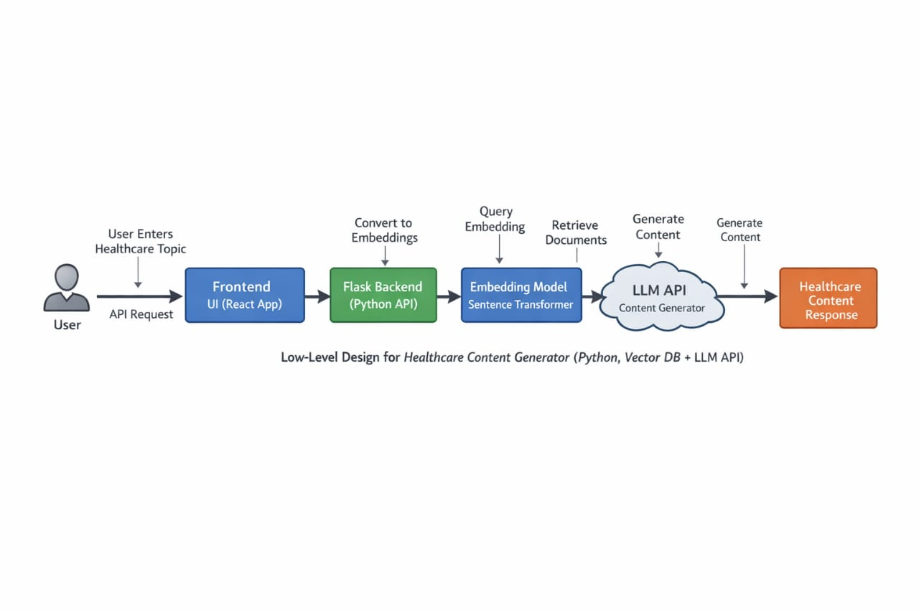

2.2 Process Flow
The process flow of the system describes the step-by-step sequence of operations through which user input is transformed into a structured healthcare output. The system follows a logical and sequential workflow, ensuring efficient processing and accurate generation of patient summaries.
The process begins when the user interacts with the system through the frontend interface. The user enters symptoms or medical queries into the input form provided by the application. This input is then transmitted to the backend server through an API request.
Upon receiving the input, the system performs input validation to ensure that the provided data is complete, relevant, and free from errors. Invalid or incomplete inputs are handled appropriately to prevent incorrect processing. Once validated, the input is forwarded to the Prompt Engineering module, where it is transformed into a structured prompt using predefined templates. This step is crucial as it ensures that the AI model receives well-defined instructions, leading to consistent and high-quality outputs.
The structured prompt is then passed to the AI Processing Layer, where a Large Language Model (LLM) processes the input. The model analyzes the prompt and generates a response that includes a patient summary, possible medical conditions, and general recommendations. The generated output is initially in an unstructured format.
To improve readability and usability, the output is sent to the Response Formatting module, where it is organized into a structured format with appropriate headings and standardized medical terminology. This ensures that the content is professional and easy to understand.

Following this, the formatted content is passed to the Report Generation module, which converts the information into a well-structured PDF document. This report includes all relevant details and is suitable for documentation and sharing purposes.
Finally, the generated output and the downloadable Doc report are delivered back to the user through the frontend interface. The user can view the results on the screen and download the report for future use.

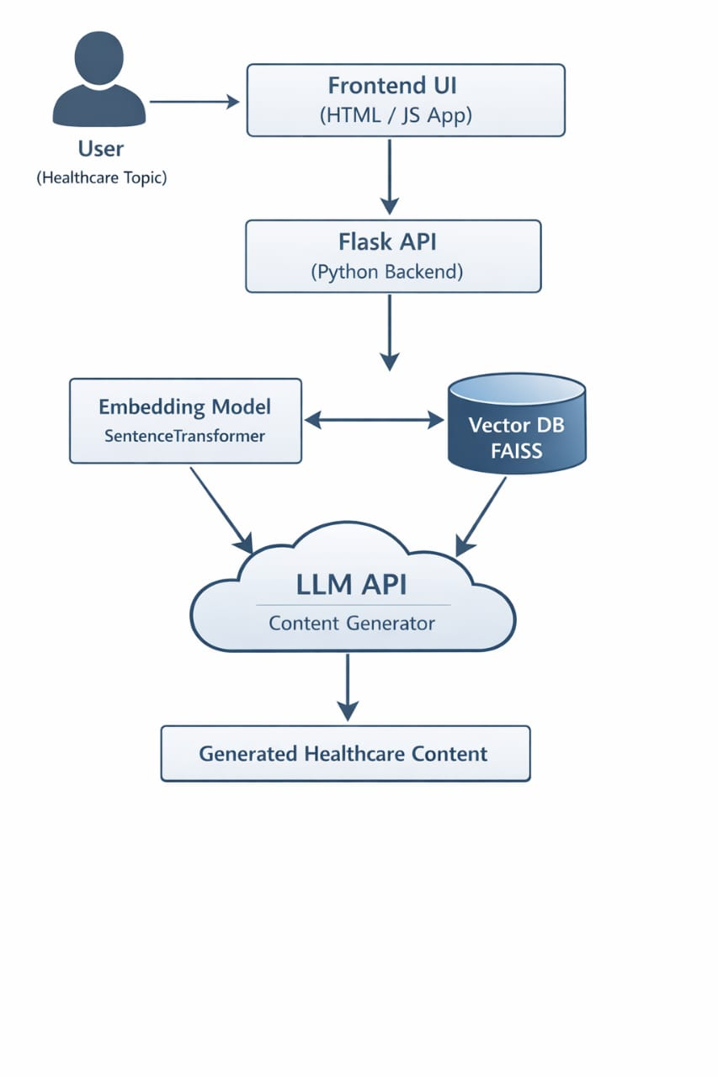

2.3 Information Flow
The information flow in the system begins when the user enters symptoms or medical queries through the frontend interface. This input data is transmitted to the backend server via API requests, where it is processed and forwarded to the Prompt Engineering module. The module converts the raw input into a structured prompt, which is then sent to the AI model for processing. The AI model generates the required output, including patient summaries and recommendations, which is then passed to the formatting module for structuring and organization. After formatting, the data is sent to the PDF generation module, where it is converted into a downloadable report. Finally, the processed information is returned to the frontend, where it is displayed to the user along with the option to download the generated Doc File.

2.4 Component Design
The system is composed of multiple components, each responsible for a specific function to ensure smooth and efficient operation. The User Interface component handles user interaction by collecting symptoms or medical queries and displaying the generated results. The API Controller component manages communication between the frontend and backend by handling requests and responses. The Input Validation module ensures that the data provided by the user is complete and accurate before further processing. The Prompt Engineering module converts raw input into structured prompts using predefined templates to maintain consistency and professional tone. The AI Processing component uses a Large Language Model (LLM) to generate patient summaries, possible conditions, and recommendations based on the input. The Response Formatting module organizes the generated output into a structured and readable format. Finally, the Report Generation component converts the formatted content into a PDF document, which is delivered to the user through the frontend interface.

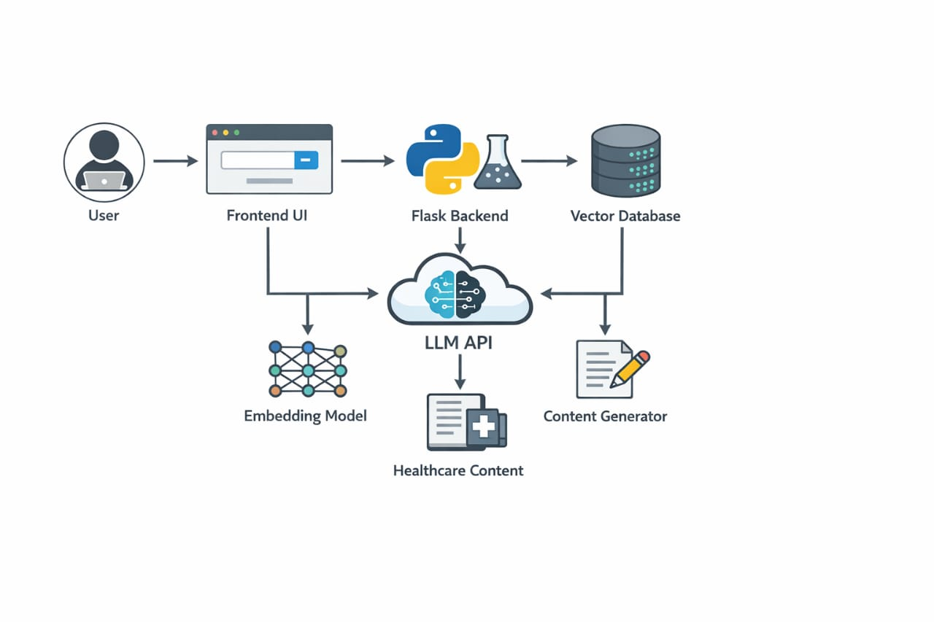2.5 Key Design Considerations
The design of the system is based on several important considerations to ensure its effectiveness and reliability. Accuracy is a primary concern, as the system must generate medically relevant and structured outputs using proper prompt engineering techniques. Consistency is maintained by using predefined templates to ensure uniform tone, format, and terminology across all generated content. The system is designed with a focus on usability, providing a simple and intuitive interface that can be easily used by both patients and healthcare professionals. Scalability is considered to allow the system to handle increased users and integrate advanced features in the future. Performance is optimized to ensure quick response generation and efficient processing of requests. Additionally, security and privacy are taken into account to protect user data and prevent unauthorized access. Finally, proper error handling mechanisms are implemented to manage invalid inputs and system failures, ensuring smooth and reliable operation of the application.

2.6 API Catalogue
The system provides a set of APIs to handle communication between the frontend and backend, enabling the generation of patient summaries and reports. These APIs follow a structured request-response mechanism to ensure efficient data processing.

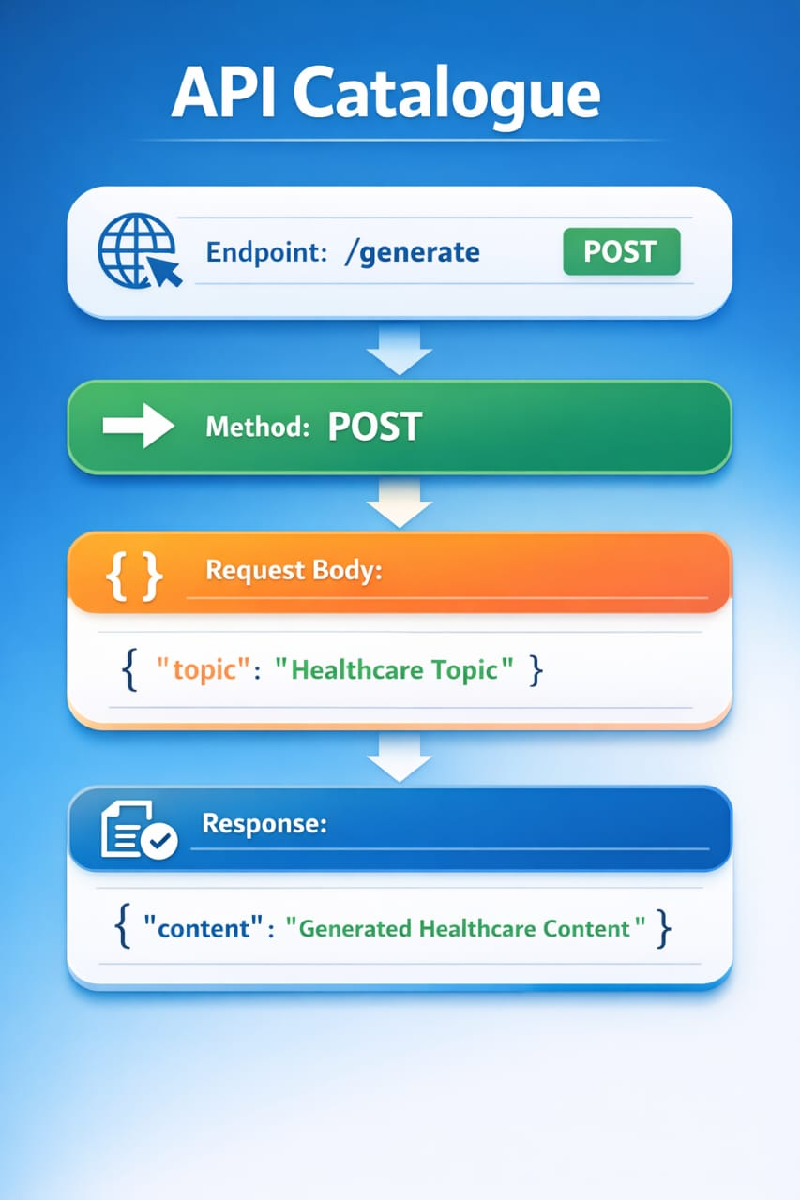

UML Diagram
